PSA, Inc.

Wireless 9000

Desktop

Tickets/Notification

Table of Contents

Ticket System 3
Authorities 3
Initial Sign On Display 3
Searching for Tickets 4
Creating Tickets 6
Editing Existing Ticket 12
Changing a Promise To Pay Schedule 14
Payments in the Promise to Pay 17
Closing Tickets 17
Reopen Closed Ticket 17
Reporting for Tickets 18
Ticket Search Report 18
Single Ticket Report 20
Promise To Pay Setup Elements 21
Clear Codes 21
Optional Bill Message for Bill Print 21
Promise To Pay User ID 21
Email Notification 22

Ticket System

The Tickets module can be used for both notification messaging and trouble tracking of service or inventory issues. The system alerts users to promises or actions that need to be addressed for certain service numbers or account numbers. The notification portion can be used with the collection process. This allows a user to record information such as a ‘promise to pay’ and the date the action should take place. For the trouble tracking, the information is more about customer issues with service or phones. This is useful to track problems either in the network or possibly with handsets etc. The codes used to create and close the tickets are user defined. They are only limited by imagination on what types of tracking you are interested in recording. Tickets are either established at the account level (for the whole account) or at the service level (specific to the service number).

Authorities
To show tickets upon sign on the user must have: Tickets – Auto Display Assigned User Tickets. All users have access to the Ticket system with additional authorities for adding, editing, changing assignees, due dates or closing tickets.

Initial Sign On Display
When the user opens a new PSA Desktop session, if that specific user has outstanding tickets, this will be the first screen they will see for this session. If there are no tickets open for them they will see the regular splash screen. The Ticket icon is the icon in the left vertical tool bar that is shown as a Bell. If it is green, neither the user nor the customer will have open tickets. If the color is red there are open tickets that should be reviewed.

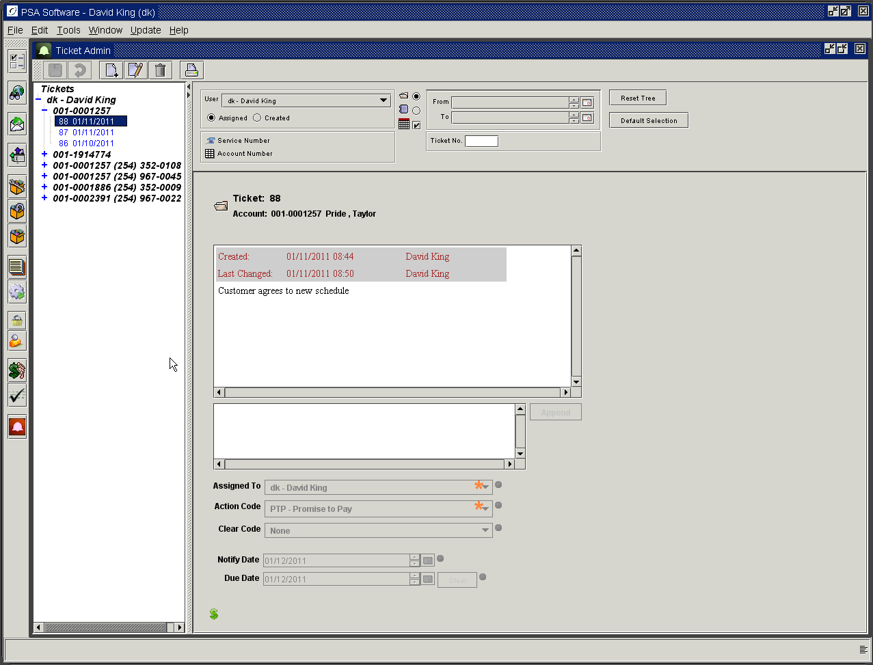

A list of open tickets will be shown in the tree on the left. The list will be shown with the account level tickets grouped together and the service tickets grouped toether. Press the plus sign to open the information on the account or service. There could be multiple tickets under either type. Highlighting a ticket in the tree will load the information for that ticket. As a default the first ticket in the list will be opened and available for review.

Searching for Tickets

The default display is to show only outstanding or ‘Open’ tickets. The open folder icon only shows tickets that are still active and not closed. If you wish to see both open and closed tickets, click on the Scroll icon radio button below the Open Folder icon in the middle of the top section. Closed tickets will then be shown in the tree on the left in light gray. Active tickets will be blue. If you want to the Notify Date considered in a search, you must check the checkbox next to the Calendar icon below the Scroll icon. Any time the user makes the changes they must press the Reset Tree button to see the results.

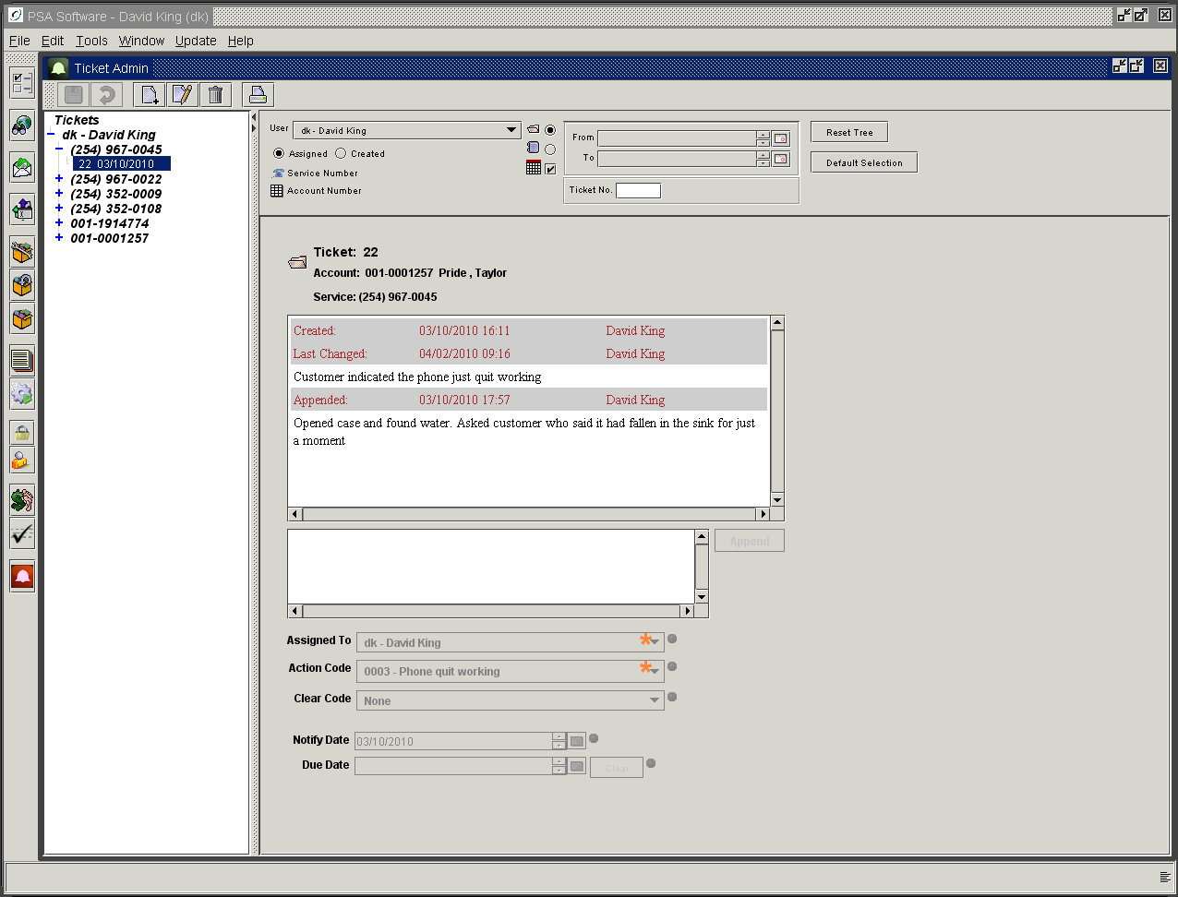

Include Closed Tickets
Open Tickets only
Search Parameters

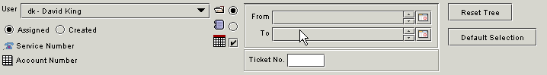
Include only tickets with an active Notify Date.

User: To see tickets assigned to other individuals change the name in the drop down box titled ‘User’. Due to limitations in memory you may not search for ‘All’ users to see all tickets. The “All” selection in that dropdown is used by the application only when searching for all tickets for a service number.
Assigned: Lists only tickets assigned to the user defined in the User dropdown.
Created: Lists only tickets that were created by the user defined in the User field.
Service Number: Pressing the icon immediately to the left will display a Search dialog box. You may search by name, account number, or service number. Choose one of the returned entries, press OK and then press Reset Tree. The service number selected from the search will display to the right of this label. Any service level tickets for that service number you highlighted will be displayed.
Account Number: Pressing the icon immediately to the left will display a Search dialog box. You may search by name, account number, or service number. Choose one of the returned entries, press OK and then press Reset Tree. The account number selected from the search will display to the right of this label. Any account level tickets for the service number or account number you select will be displayed.
Open Tickets Only: Lists only active tickets for User.
Include Closed Tickets: List includes both active and cleared tickets for User.
Include only Tickets With Active Notify Date: When checked this option shows only tickets where the Notify Date is today’s date or a date in the past. Future dated tickets are not displayed. Closed tickets are not displayed with this option set to On. Remove the check to see all tickets for a selection.
Date Range: This will display only tickets with create dates with in the date range. A wide date range can slow or impair a return listing; especially where a large number of tickets are created annually. For best results, limit the date range selection to as small a range as possible.
Ticket Number: If you know the ticket number you are looking for enter that number in this field and press Reset Tree.
Reset Tree: You must press this button to initiate any changes made to the search criteria. New entries using the new criteria will be displayed in the tree to the left.
Default Selection: To return to the default settings, clearing any dates set or search assignments, press this button and then Reset Tree.

When looking at the returns after a service or account number search, the TC column in the returned list shows the number of tickets currently open on that service. This count can consist of service level tickets, account level tickets or a combination of both. Highlight the line item and press OK to return the ticket listing; remember to press Reset Tree to activate the search with the new parameters.

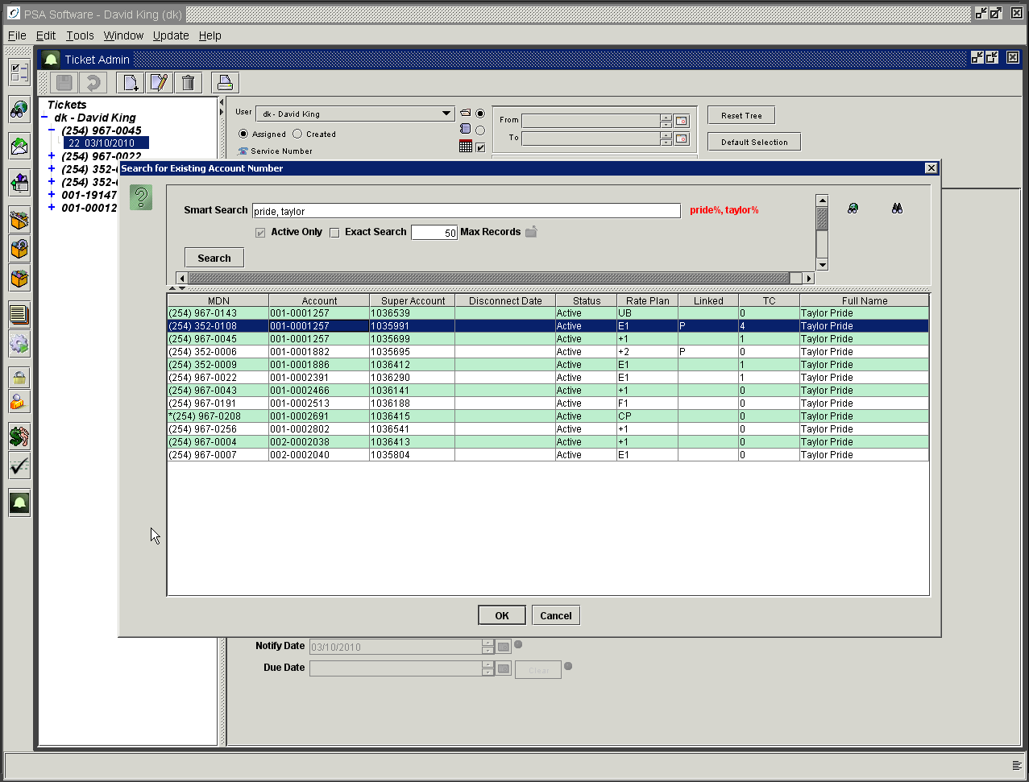

Creating Tickets

If the customer selected does not have any outstanding tickets, the icon will be green. Once a ticket has been established on a customer the Ticket icon will be shown in red until the ticket is cleared. You will be able to determine if a customer has any trouble tickets for the service by checking the “TC“ column on the initial search screen. This column indicates the number of open tickets on that service number.

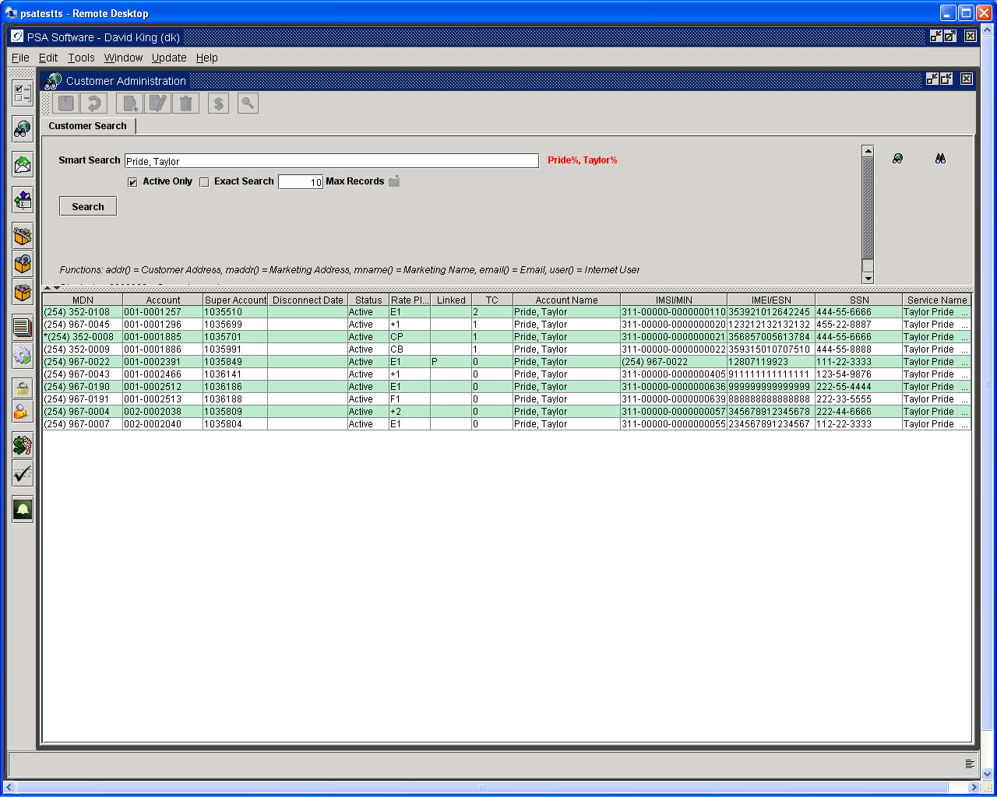
TC is the number of open tickets.

Open the service number and press the Ticket icon to open the ticket interface.

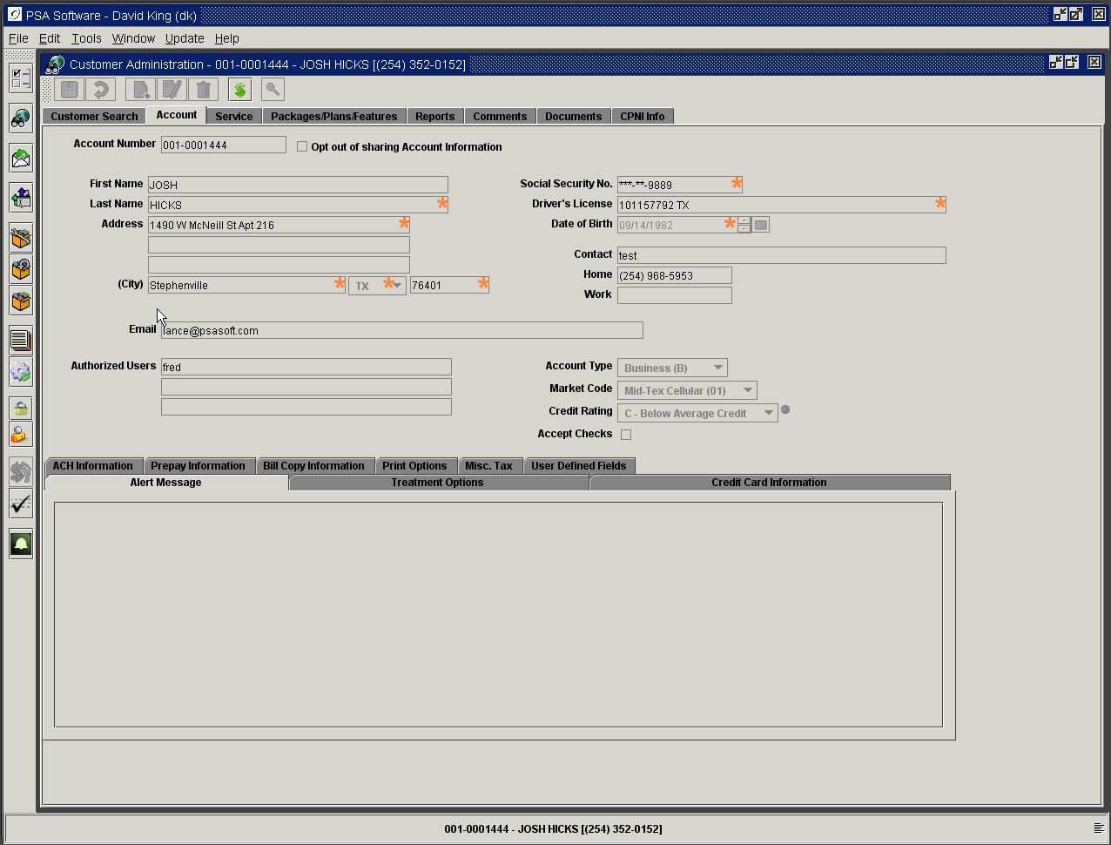

Any old open tickets will display in the tree. Press the New icon in the top tool bar to initiate the new ticket.

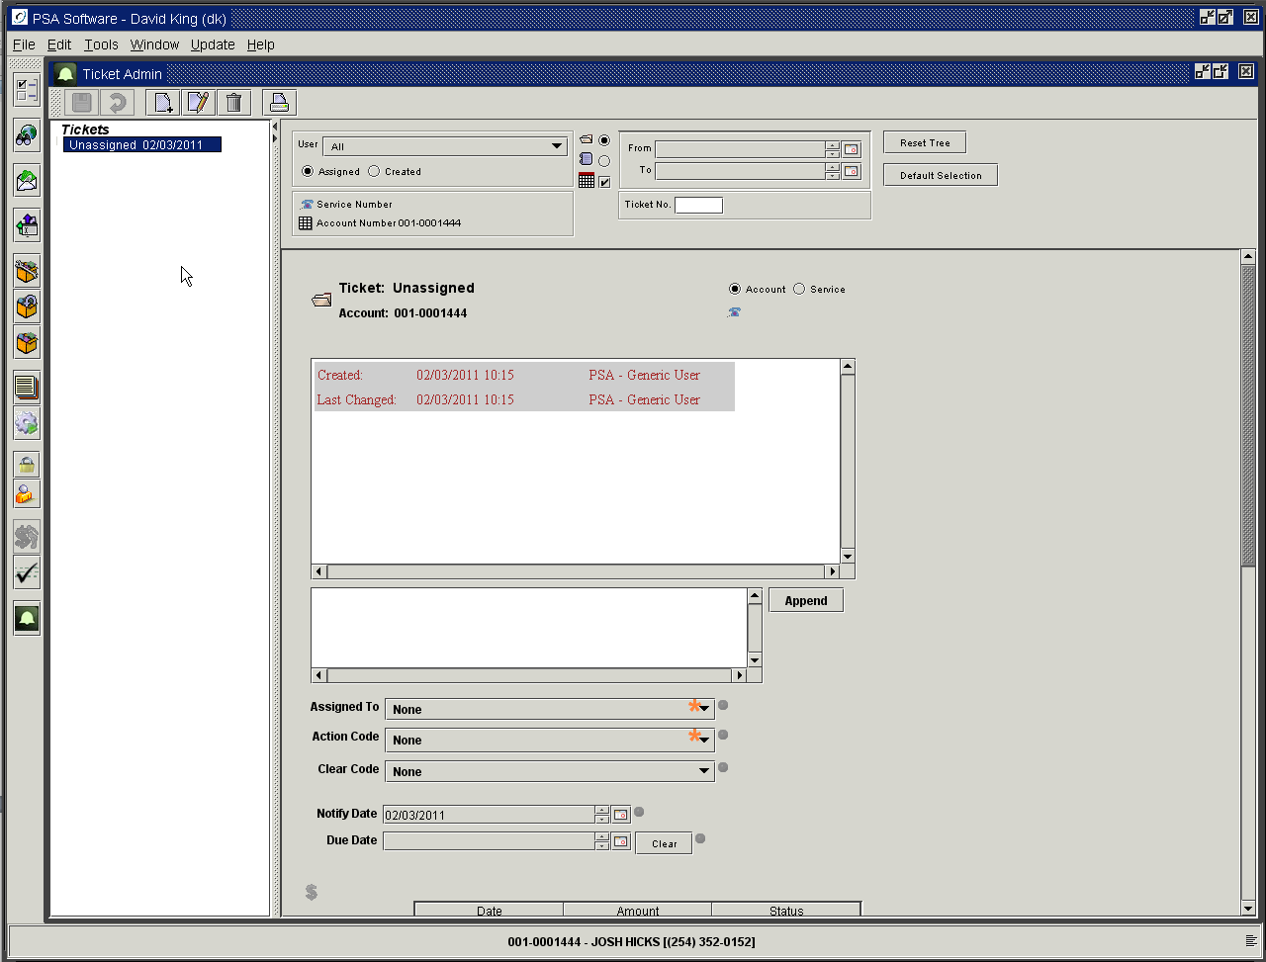

The Ticket number will remain unassigned until you save the ticket. The Account number or Service number will be shown immediately below the Ticket number field. If you want the ticket to apply to the whole account, check the radio button to the left of the Account field. The account number of the open customer will display under the Ticket number. Promise to Pay tickets would be examples of account level tickets.

If you check the Service radio button then both the Account Number and Service number will display.

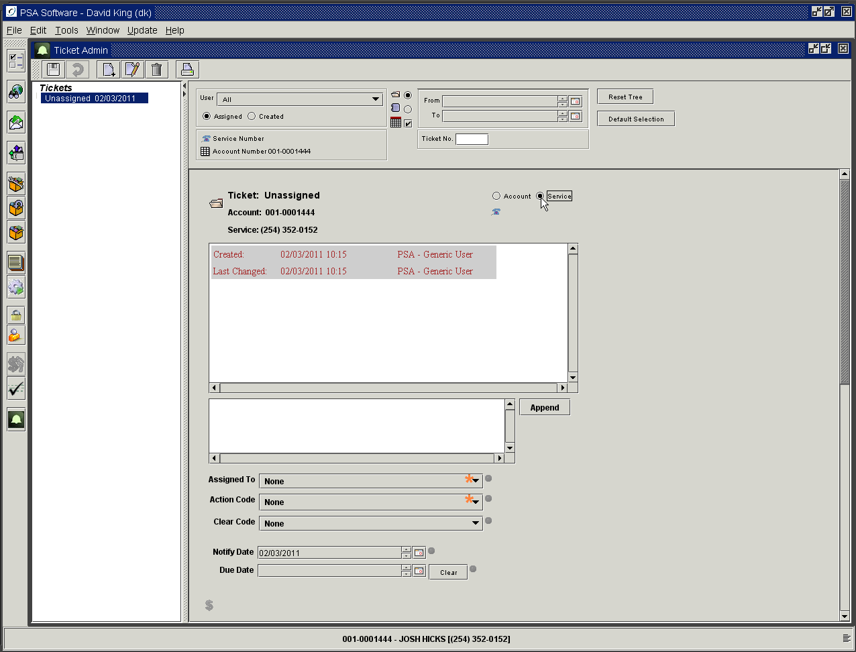
Account level or Service level selection
Search Dialog request

When the service radio button is selected, then the information on the ticket will specific only to the service number shown under the Ticket number field. Trouble tickets are usually service level tickets.

Pressing the Telephone icon immediately below the Account or Service level selection will present a search dialog box to find a different account or service.

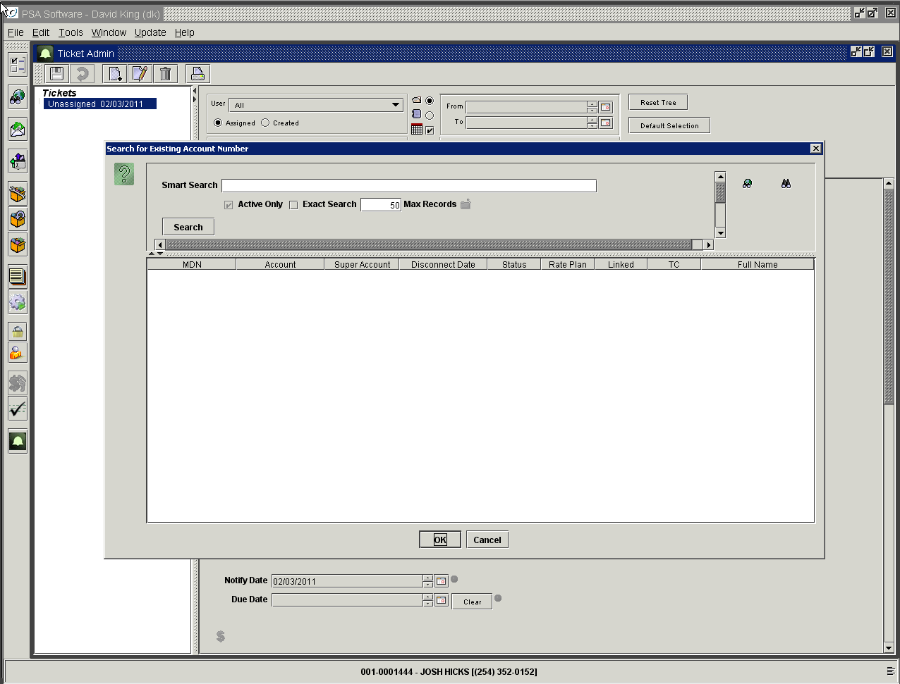

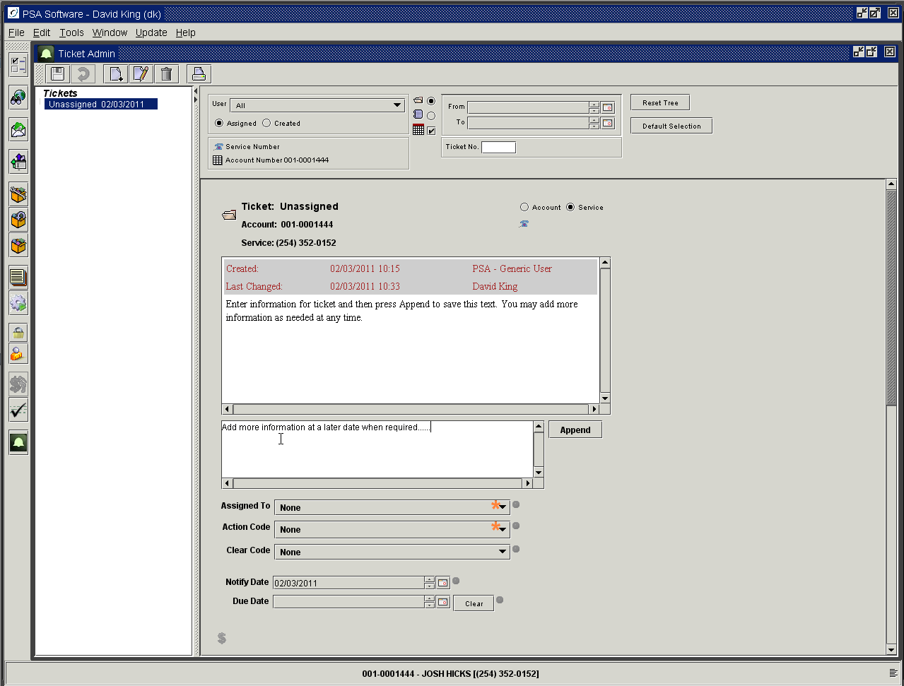

The first text field contains all the saved data regarding the ticket. As information is appended to the ticket or codes are changed, those changes are recorded here and are not editable. In the second text field explain in as much detail as needed the reason for the ticket and/or add new updated information. Once information is entered the Append button will be active. Pressing Append moves the information to the first box.

Assigned To: Here you will select a user in your company to be responsible for following up on this ticket.
Action Code: Select a code description that most closely represents the situation. Some Ticket codes are specific to the level of the ticket. (Ex. Promise to Pay is only available for Account level tickets)
Clear Code: Once a ticket is no longer needed you should select a Clear code the represents the resolution of the ticket. Selecting a code and subsequently saving the ticket will close the ticket to an inactive status. To reactivate the ticket, find the ticket and remove the clear code. Press Edit to update the closed ticket. Open the Clear Code dropdown and press the up arrow on your keyboard until the field is blank. Pressing save at this open reopens the ticket for further consideration.
Notify Date: This date establishes when the ticket will begin showing in the ticket tree. If you set this date a week in the future, the ticket will remain hidden until the date is reached.
Due Date: This date establishes when the ticket requires an action. Using Promise to Pay as an example; if this date passes without a promised payment then the application will take action defined by your company.

‘Promise to Pay’ Tickets are a specialized type of ticket, which can perform specific tasks as designed by your company. Select Promise To Pay from the Action Code dropdown to create the ticket. Promise to Pay can add/remove accounts from the suspension file. These tickets can have multiple due dates for payment scheduling. Logic has been added to check the payment file to confirm or deny a scheduled payment has been made and then take the appropriate action. PSA will work with your company to determine how much automation you would like to allow in Promise to Pay. Promise to Pay can but is not required to contain a schedule of payments. There can be one or more promised payments in a schedule. To create the schedule, press the green dollar sign icon at the bottom of the ticket.

$ Icon: The application allows you so setup a schedule for Promise to Pay ticket types. Pressing the $ icon will display a dialog box to enter the schedule.

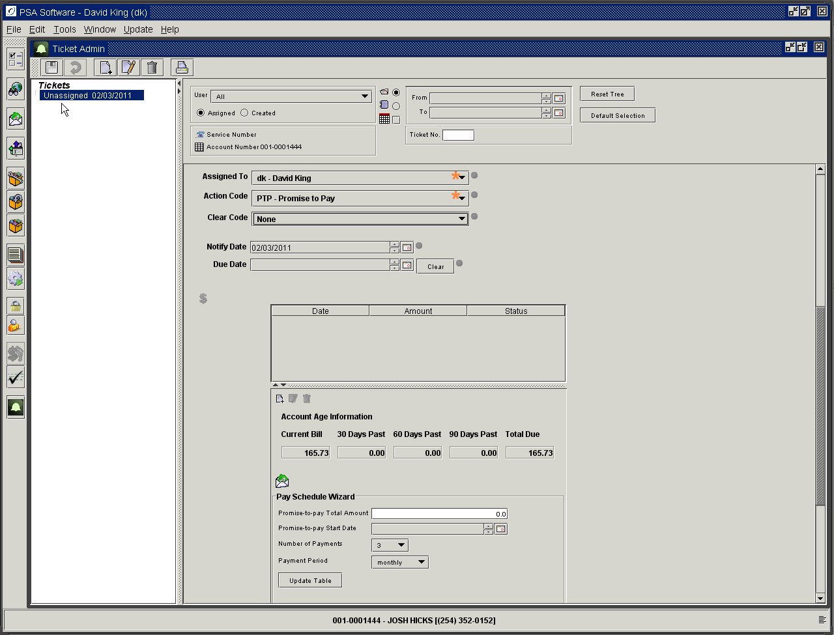

You have within the Promise to Pay the New icon, Edit icon and Delete icon. This will control the items within the wizard only. You will allow see displayed the current account receivable balances for this account.

After saving the ticket you will be able to access the ‘Payment History’ report using the Envelope icon above the Wizard.

Pay Schedule Wizard
The wizard will help define amounts needed to cover the amount of the promise to pay.

Promise to Pay Total Amount: Enter the total amount the customer is going to pay to clear the promise to pay.
Remember if you are scheduling payments across bill cycles to take into account the additional owed created during the current cycle. (Example: if the balances are as follows 100.00 current due, 100.00 30 days past due, 100.00 60 days past due and you are going to allow them two months to catch up, you must consider that the next billing will add an additional amount to the overall total the customer will owe to catch up. So if the average monthly charges is 100.00 then you should enter 500.00 in the Promise to Pay Total Amount – 300.00 existing debt plus 100.00 for each of the two additional months required to pay off the total owed.)

Promise to Pay Start Date: Select the starting date of the promise to pay.
Number of Payments: Select the number of payments for the total amount to be broken into by the type of period. If you are going to allow 2 monthly payments, select two here and Monthly in the next field.
Payment Period: Select from Weekly, Bi-weekly (every other week) or Monthly.

Update Table: After selections are made press the Update Table button and the new schedule will be displayed for review.

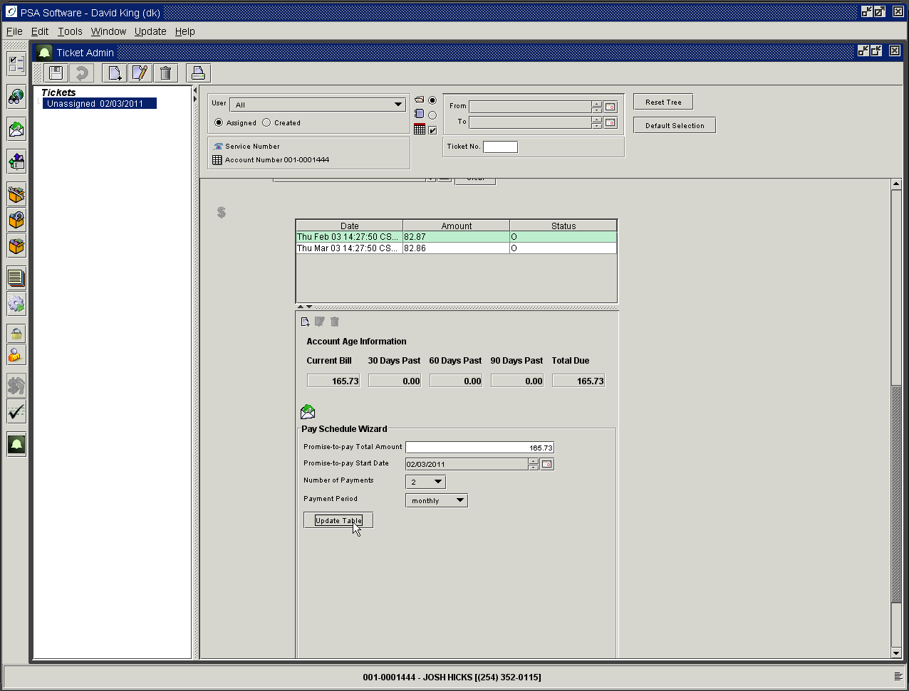

The final step is to press Save to complete the creation or updating of the ticket. Pressing Reset Tree will refresh the ticket tree and the new ticket/notification will appear.

Editing Existing Ticket

If changes need to be made, the user can press the Edit icon on the top tool bar.

Once the ticket is in edit mode, you may change the Assigned To, Ticket Code, Clear Code or add more text to the ticket. You may change the Ticket Code as needed over the life of the ticket until the ticket is closed. Ticket code will be one of the various codes indicating trouble or other types of incidents. Select the code that most closely represents the situation.

To add information to an existing ticket, press Edit. You may now enter text into the second text box.

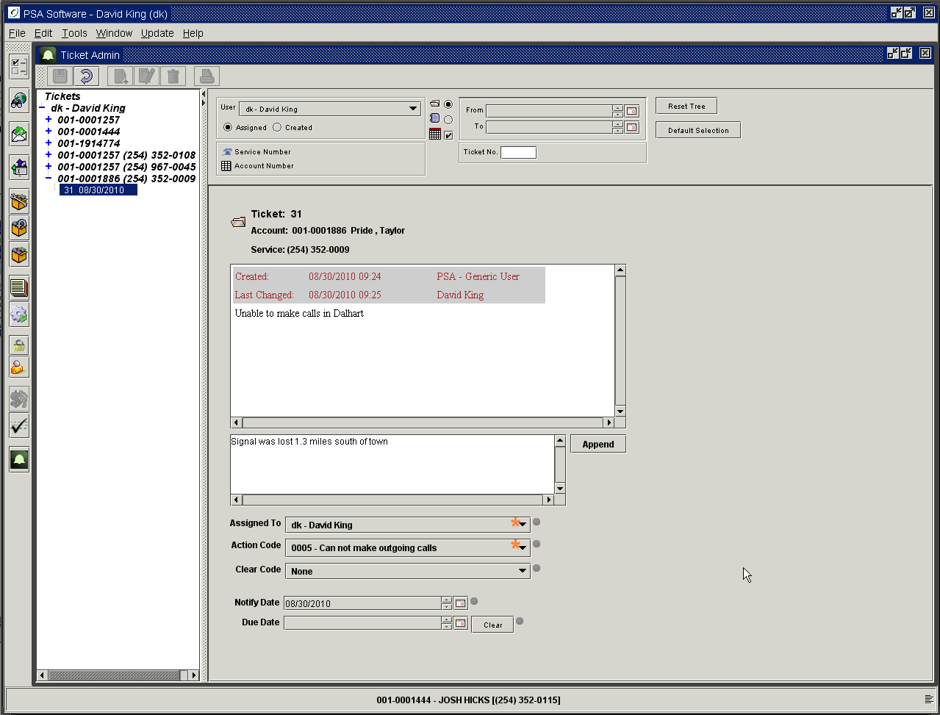

Pressing the Append button will commit the new text to the ticket history shown in the text box immediately above. The new information will show as Appended with the date and User Id of the person entering the new information.

Once the ticket is saved the text cannot be changed. The user can add new text but existing text is not editable.

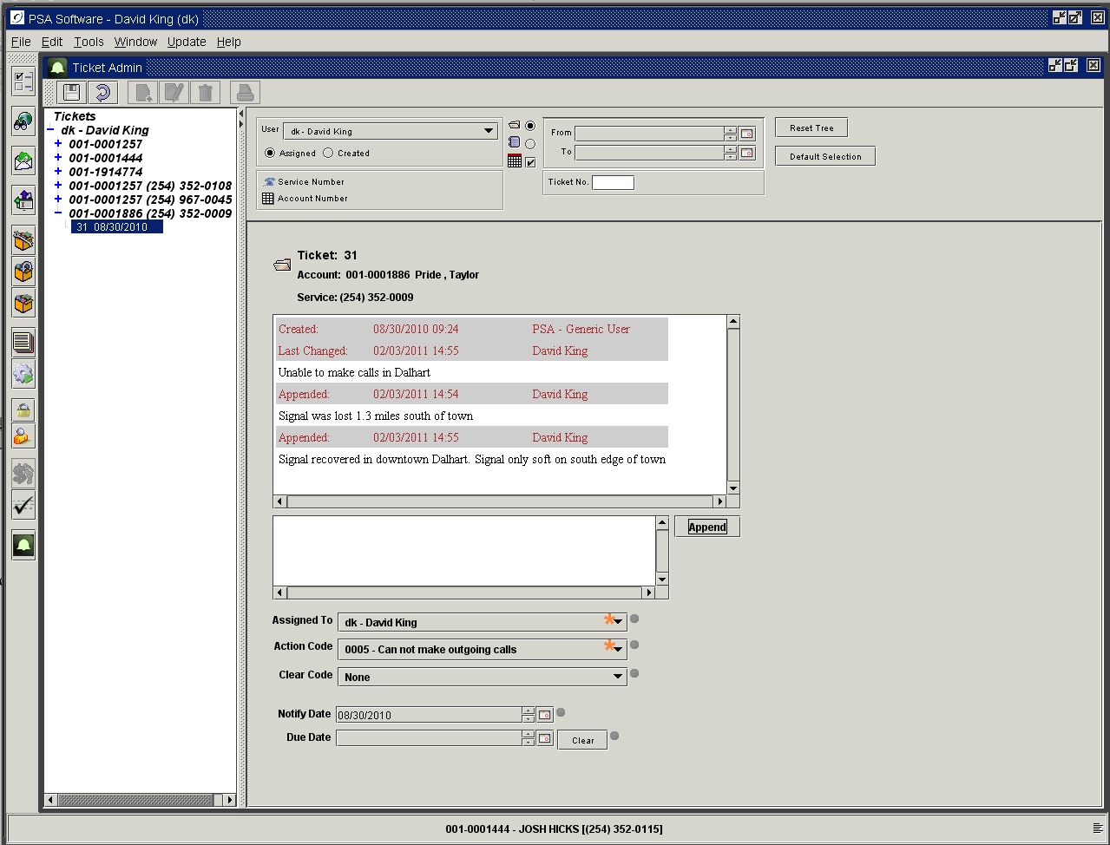

Changing a Promise To Pay Schedule

Find and highlight the PTP ticket in the ticket tree. Press the Edit icon in the tool bar and press the green $ icon on the ticket to see the schedule.

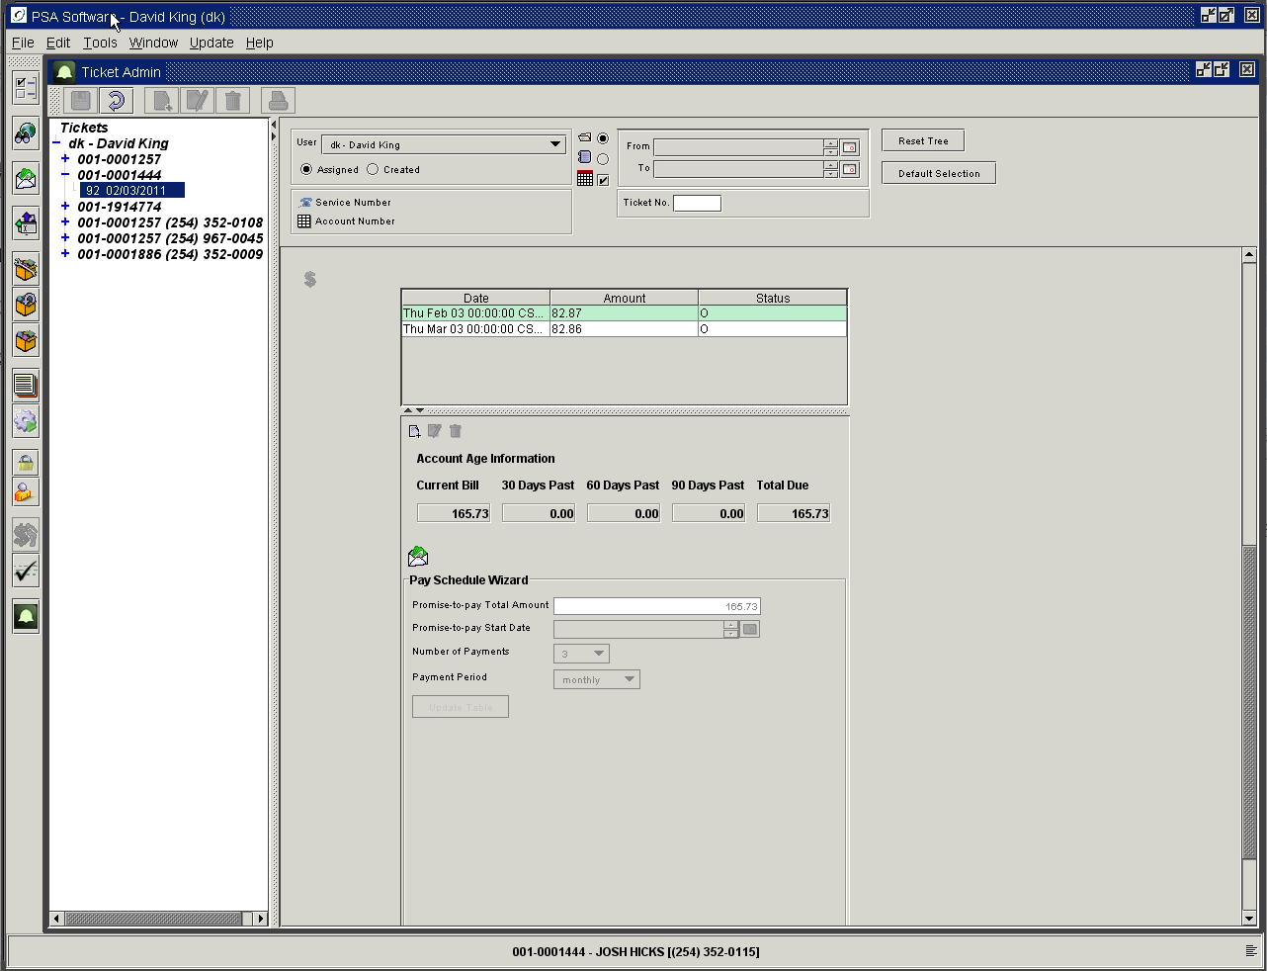

You may pull up a Payment History report by pressing the Envelope icon.

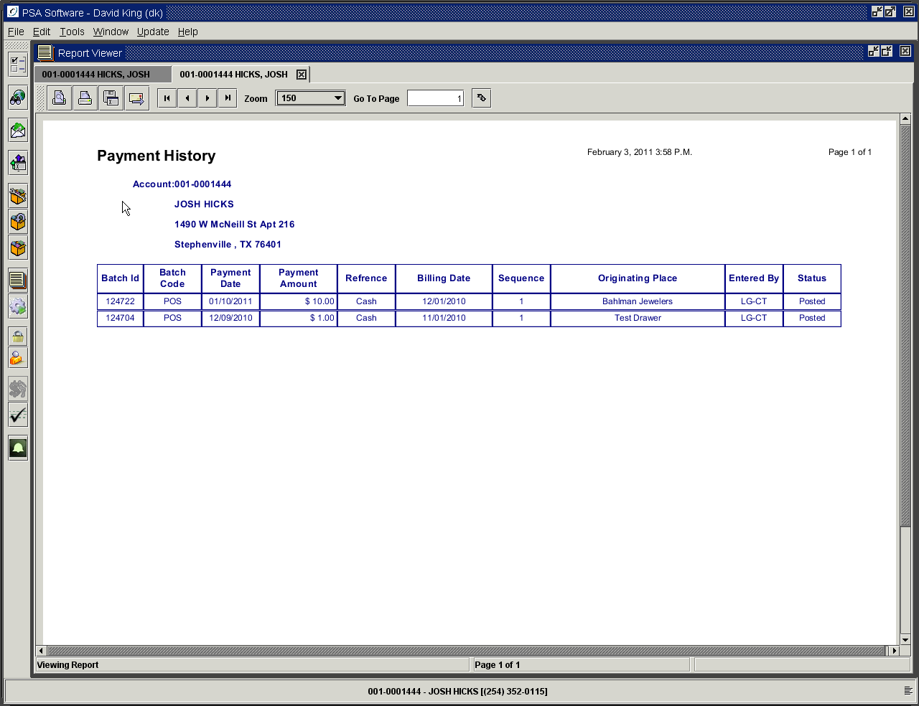

To alter a payment amount select the payment in the table; this will activate the Edit icon and Delete icons in the wizard. Changing one component of the Promise to Pay does not update any other components in the schedule. Each payment must be managed individually once the schedule is created.

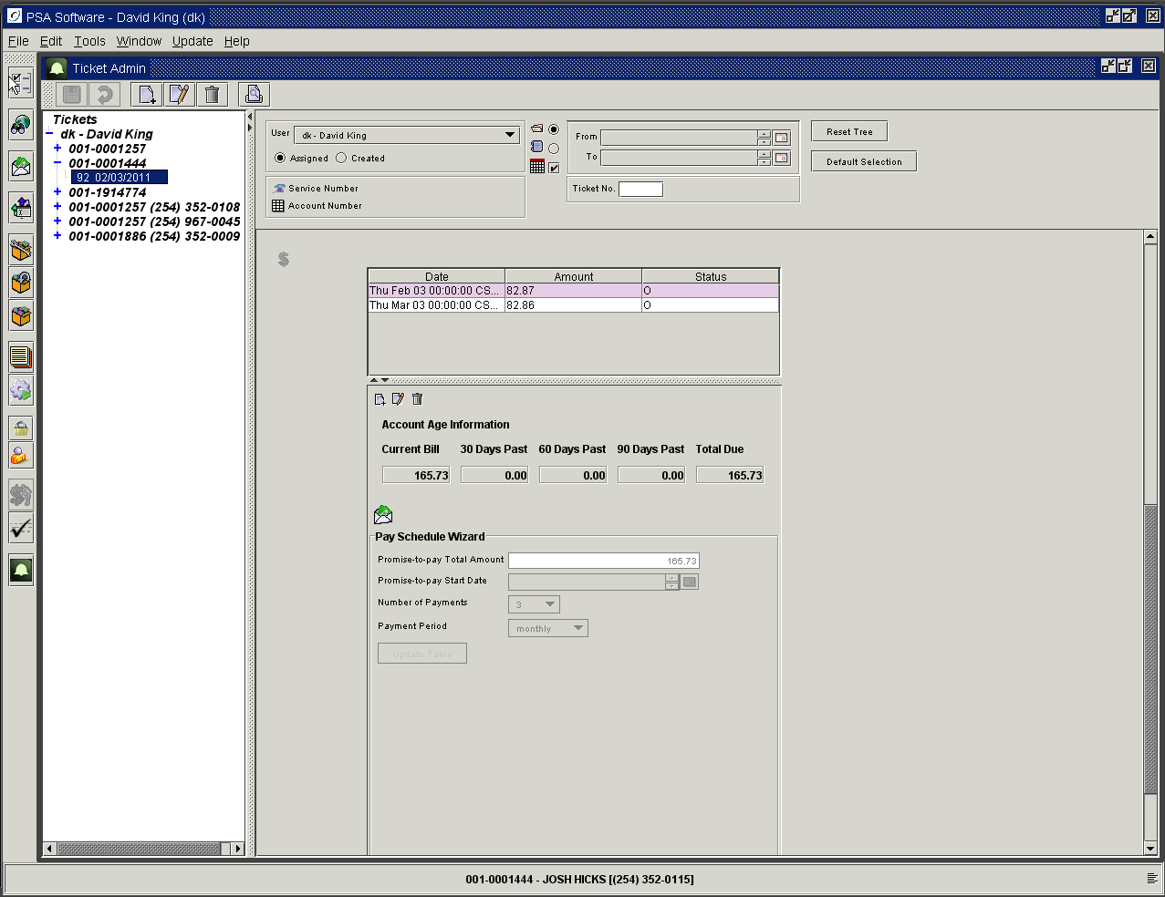

Press Edit to change an amount

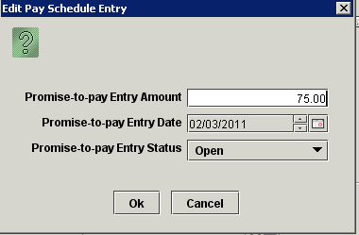

Change the amount and/or date as needed and press OK to change this single entry. If this is the only change you intend to make then press Save to post the change. If you change the status to closed the application will not consider this entry in any of the logic regarding suspensions etc. The Desktop will monitor this scheduled entry and when the payment has been made to satisfy this promise, the program will change the status to closed. Closed status indicates the payment was received as promised. This should not be changed by CSR unless instructed by supervisor. Notice that the second scheduled payment amount was not altered when the first entry was edited. You must press OK and then Save to change the table entry. Using the Trash Can icon to delete items should be used if you need to remove an entire schedule to recreate a new one. Care should be used when deleting individual entries; this may cause the Promise to Pay application not to perform as expected. Deleting a scheduled amount only removes that entry; no other balances are adjusted to compensate for the deletion.
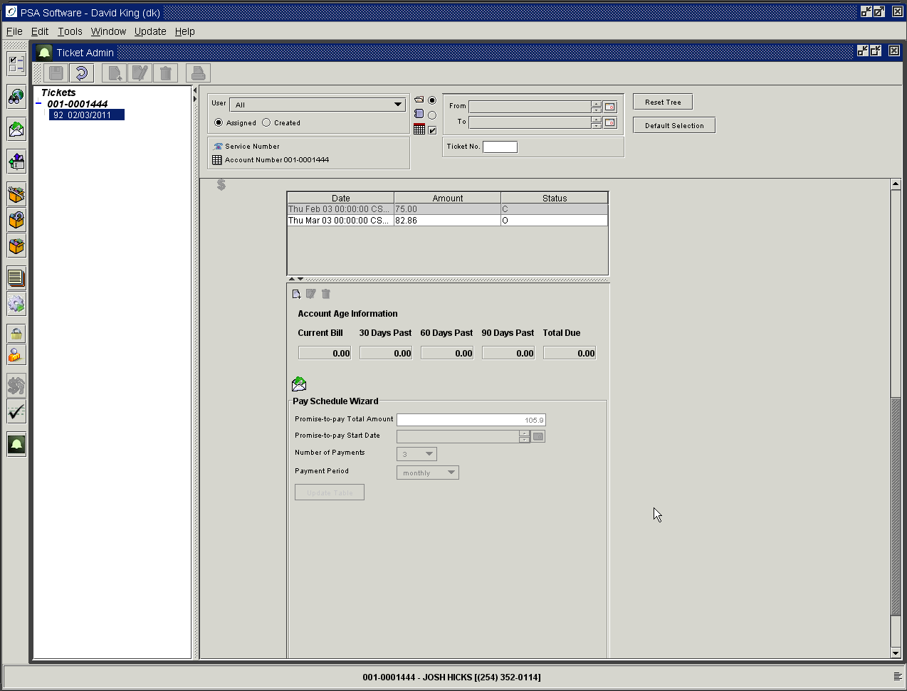

Payments in the Promise to Pay

If a schedule is not created then the Promise to Pay cannot control the suspension process. Sometimes multiple payments are not required so enter the total amount and select 1 payment. Only one line entry will be produced. The application will then check for payments that will fulfill the promised amount. If the amount is satisfied then the ticket will be closed and no other action will take place. Payments will close individual line entries or the entire Promise to Pay ticket when all payment arrangements have be fulfilled. If partial payments are accepted the application will deduct the amount of the payment from the original promised amount and adjust the balance for this line entry in the schedule table. If a payment amount is greater than the scheduled payment, the overage amount will be applied to the next scheduled payment.

Closing Tickets

Initially the Clear Code will be set to ‘None’. Once the ticket has been resolved you will need to select a Clear Code. Selecting a Clear Code and pressing ‘Save’ will mark the ticket as complete. The ticket will be archived to the ‘Closed’ status and marked as gray in the tree. Select the Clear Code that most closely represents the resolution of the ticket.

Reopen Closed Ticket

To re-open a ticket, uncheck the ‘Include Only Tickets With An Active Notify Date’ box and press the Reset. This displays the closed tickets for this customer or CSR. Select the ticket to be re-opened in the tree and press Edit. Change the Clear Code to “None” and press ‘Save’. The ticket is now active for modification.

Due to the complexity of the Promise To Pay system, PTP Tickets that were closed because the payment was not received according to the schedule established on the ticket cannot be reopened.

Reporting for Tickets

There is a new section under the Reports Module - Ticket Reports.

Ticket Search Report

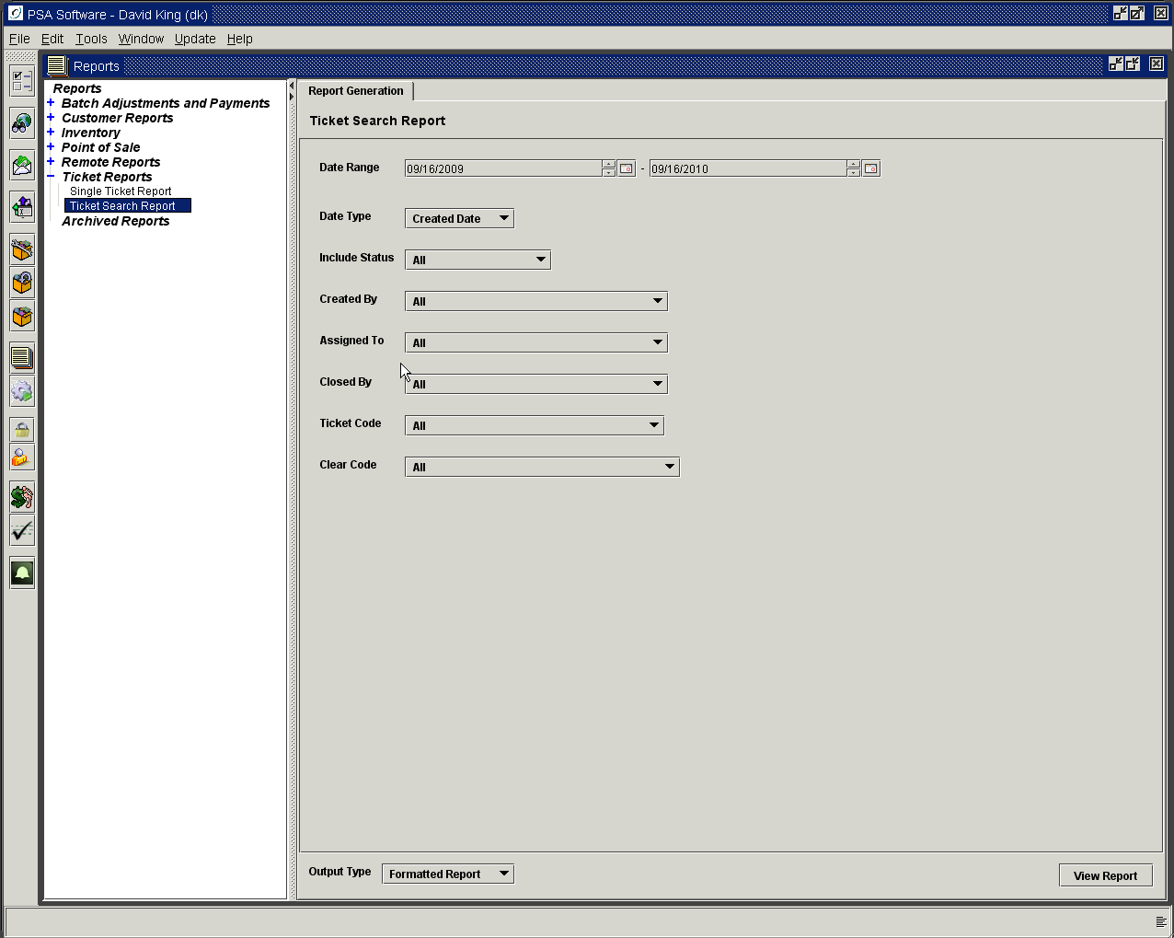

Enter the requested parameters and press View Report. The filters are not mutually exclusive, meaning you could ask the report to return all the tickets that were created by DK, closed by LG for the code reason ‘No Service’ and cleared for ‘Tower back in service’. You may stack the filters for this report. The report can be created as Formatted report or CSV. The report can be printed or emailed.

Date Type: Options are Created Date, Notify Date or Due Date.
Include Status: Allow selection of All, Active Only or Active and Cleared Both.
Created by: Finds all the tickets created by the individual selected.
Assigned To: Finds all the tickets assigned to the individual selected.
Closed By: Finds all the tickets closed by the individual selected.
Ticket Code: Finds all the tickets with that selected trouble code.
Clear Code: Finds all the tickets that this code was used to close a ticket.
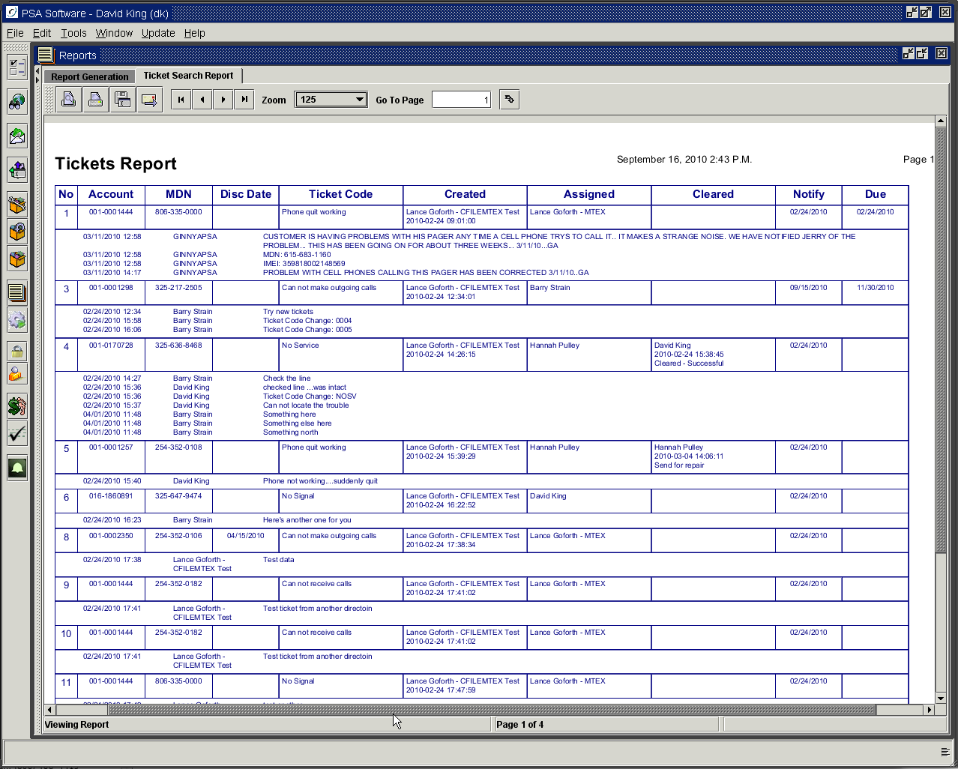

Single Ticket Report

Returns the information for a single ticket for printing or emailing. Enter the ticket number and press Retrieve Report.

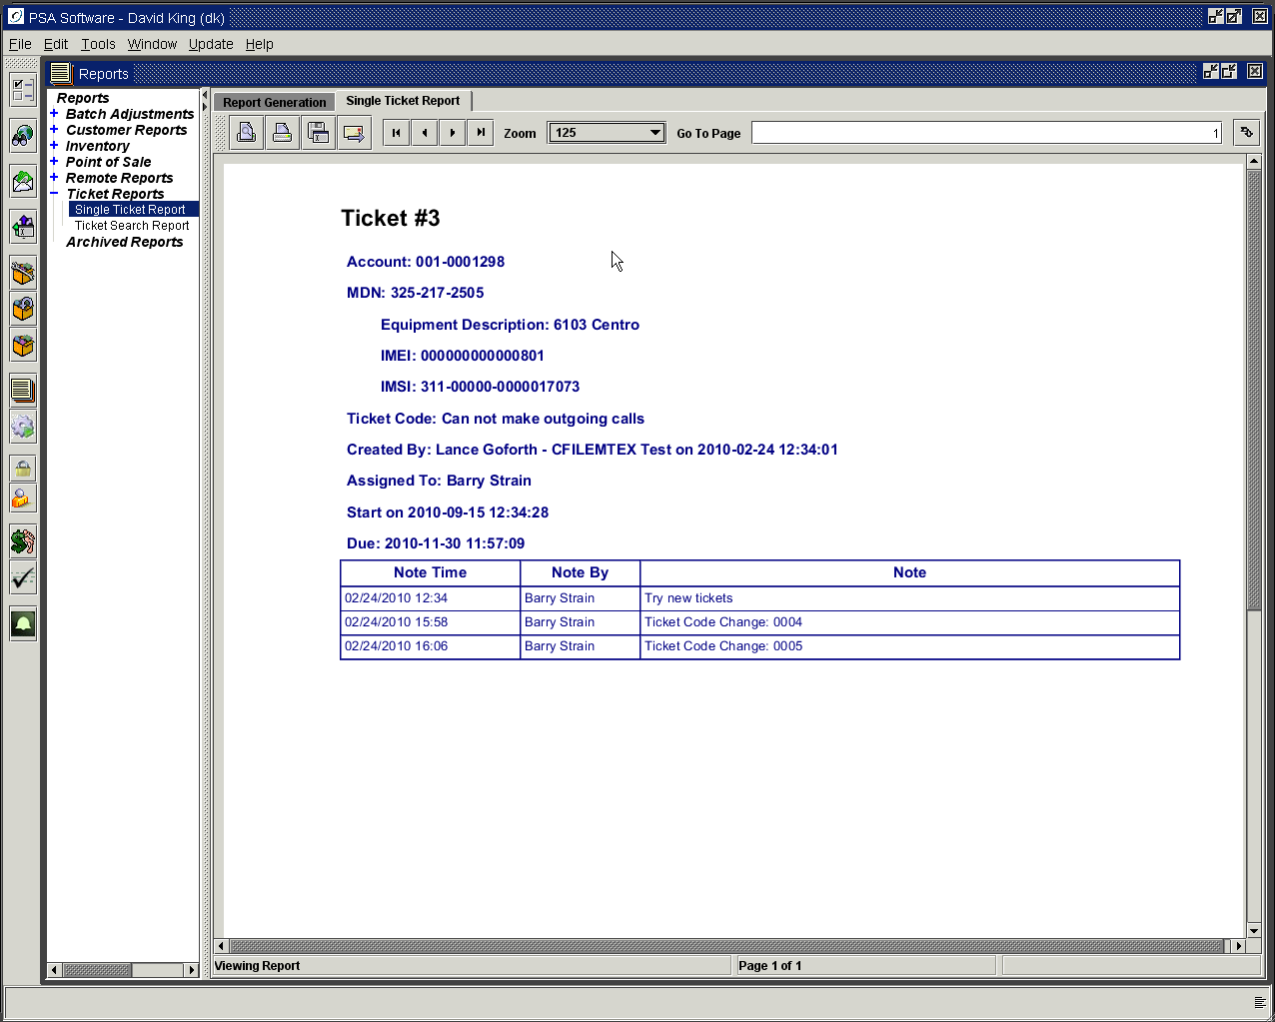

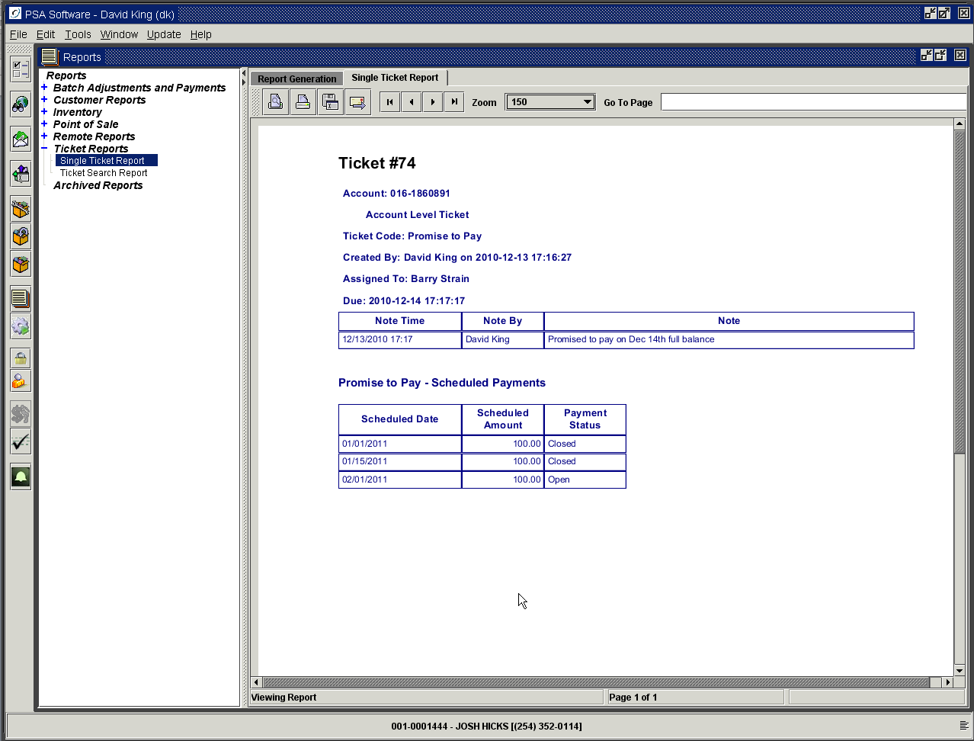

Promise To Pay Setup Elements

Promise to Pay requires some additional setup to control the functions with in the system.

Clear Codes

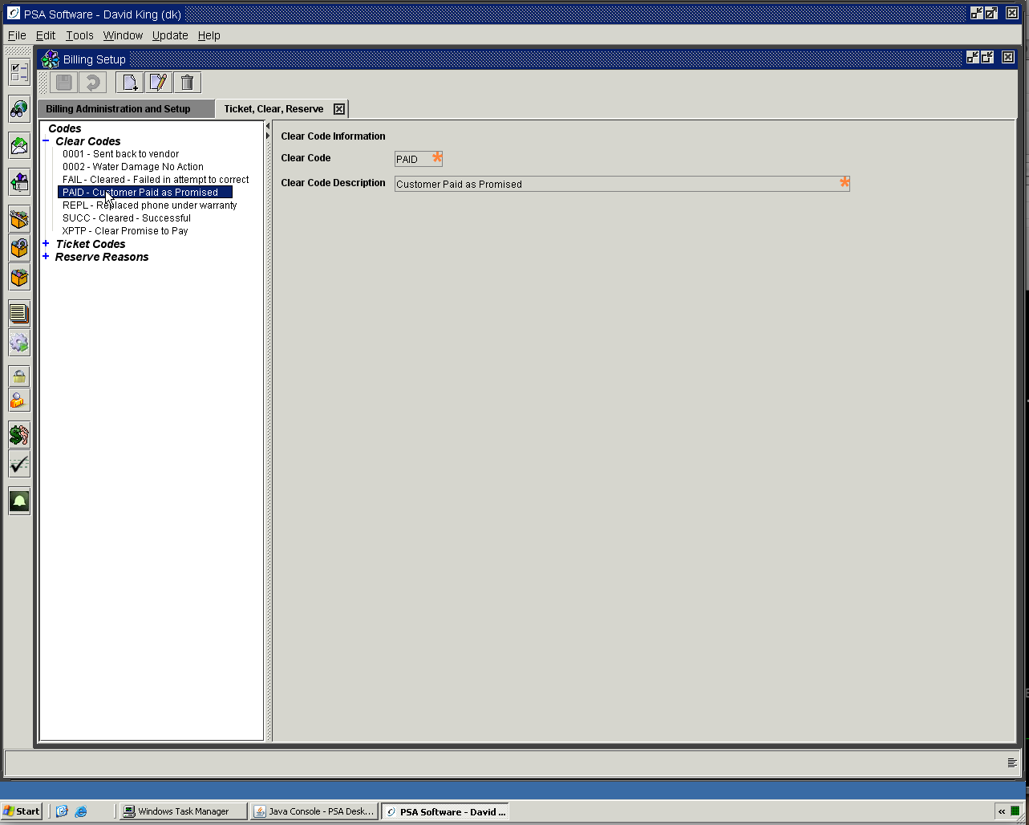

Two clear codes must be created to be used by the application: PAID and XPTP. These four character codes are required by PSA; you may enter any description you wish for each code.

Optional Bill Message for Bill Print
Alternate messaging for Promise to Pay is available but requires setup by your company and PSA. If you want the Promise to Pay tickets to override the Notification system for messaging on billing statements, then PSA must create the message code “PTP” to allow a different message to be sent in place of the normal bill message. If you use OSG to create your statements this code and corresponding message must be setup on their messaging site as well. Example: If the customer is 60 days past due but has a promise to pay ticket, you could send a message “PTP” indicating your company is aware of the scheduled payment etc. and not send the disconnect message “C01002” normally associated with a 60 day past due account. If you do not want to override the messaging then ask PSA not to create the “PTP” code.

Promise To Pay User ID

You need to create a user id to be used by the application for the Promise To Pay functions. You must have one user id; but might want two ids (one for Paid and one for Suspension) The PTP system that checks the PTP tickets every night will be making changes within the system. If a ticket is closed due to a payment arrangement being met that entry could be labeled PAID888. If the arrangement is not met you could have a user id XPTP555. Or you can opt for one user id PAID777 and XPTP777. Once you create the id PSA will get the actual code to append to the PAID and XPTP. This id will be shown in the comments for each action. Please create the ID and let PSA know what the user name is that is associated with the each type.

Email Notification

The ticket system will send notifications as tickets are created and/or updated. The notification texts are created under Options>Notification Text. For the email to work each user needs to have an email address setup on the user id under Security. The subject line will contain the ticket number and account number/service number.

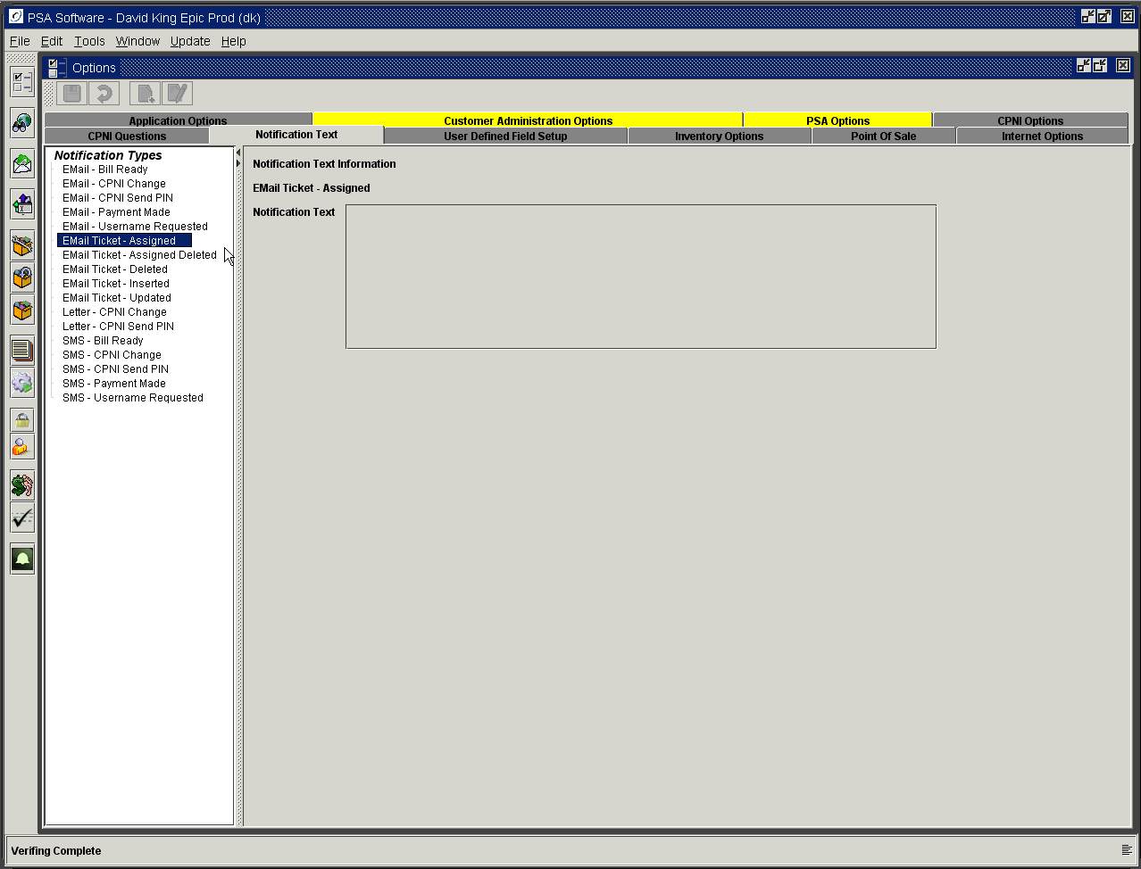

Email Ticket – Assigned: this will be the notification when a ticket has been assigned to the user.
Email - Assigned Deleted: notifies the assigned user that a ticket has been deleted.
Email Ticket – Deleted: sends email that a ticket has been deleted to the creator of the ticket.
Email Ticket - Inserted - sends email to creator confirming ticket creation.
Email Ticket - Updated - sends email to creator of the ticket when any update is done on the ticket.

If you don't setup a message the email will show the Ticket #, Account # and/or Service number in the Subject line but the body of the email will be blank.

